RESUME

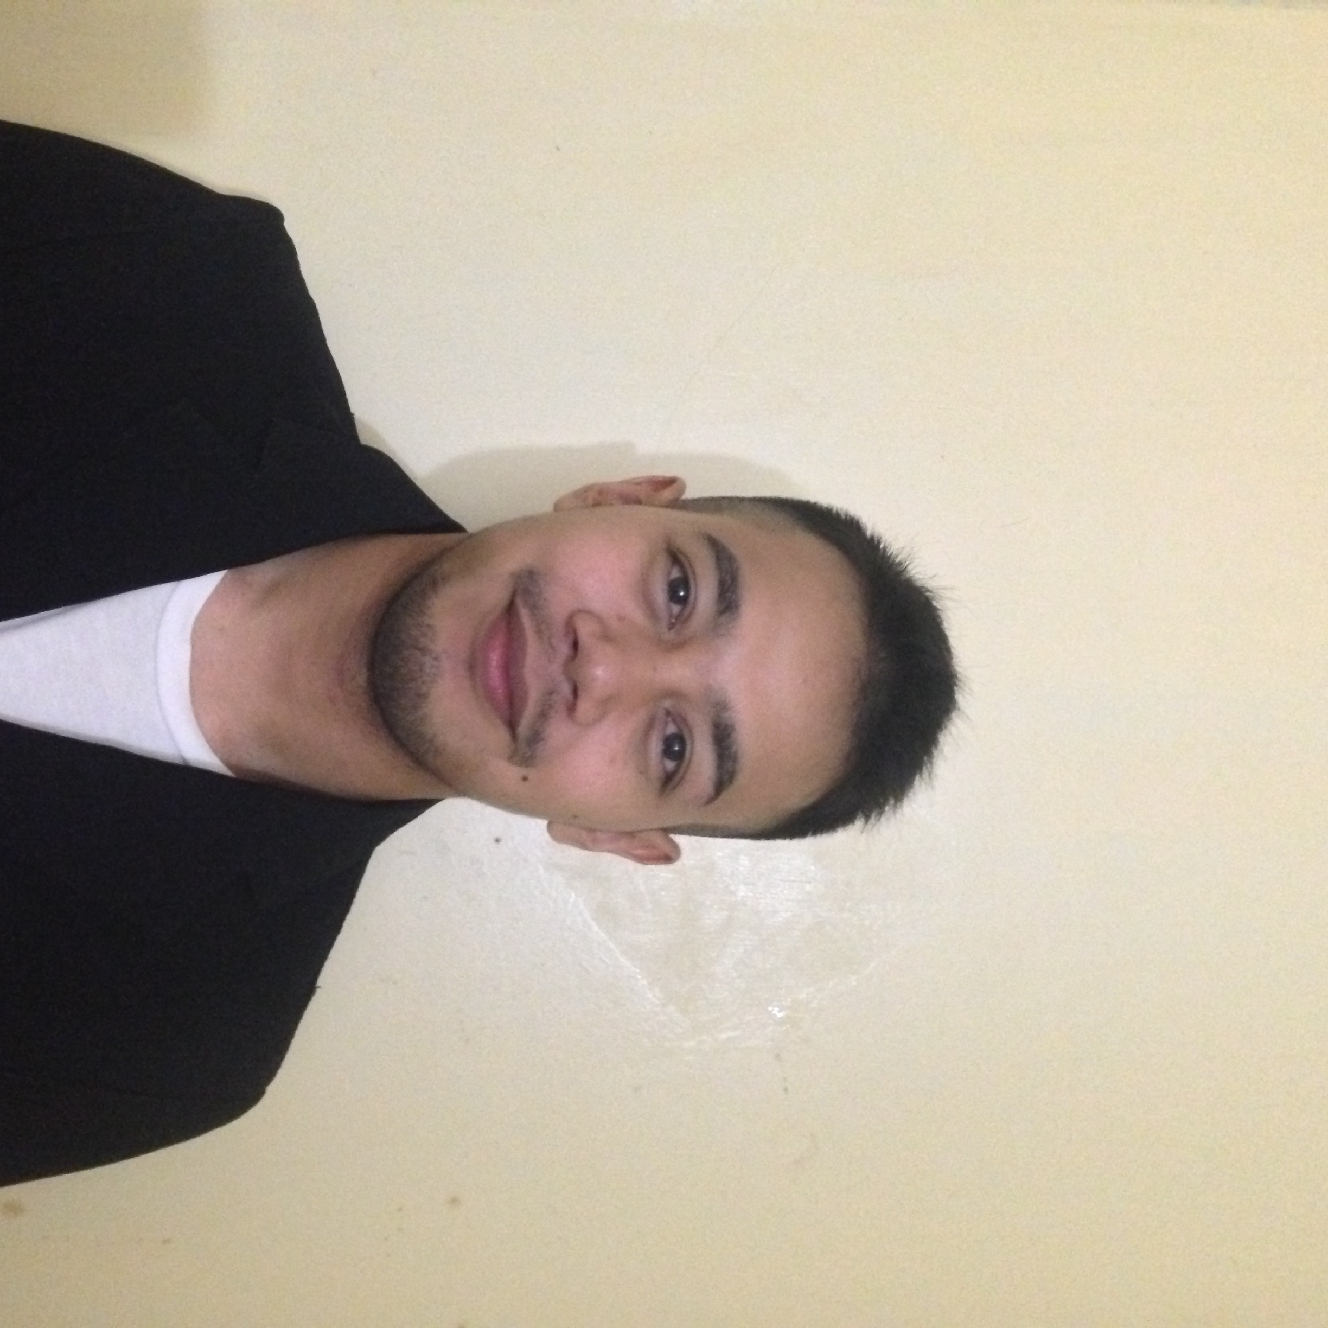

MOHAMAD FAIZ BIN MOHAZAM

PERSONAL PARTICULARS

IC No : 941007-14-5881
Address : No.19 Jalan DM 1/5 Taman Desa Mas, Bandar Country Homes,
48000 Rawang, Selangor
Telephone No : 019-3151489
E-mail Address : aezmag1994@gmail.com
Age : 22 Years
Marital Status : Single
EDUCATIONAL BACKGROUND

June 2013 – April 2016 | Diploma in Engineering Electronic (Computer)  Politeknik Sultan Azlan Shah (PSAS) | Last sem 6 result : 3.35
2007 - 2011 | Sijil Pelajaran Malaysia (SPM)  Sekolah Menengah Kebangsaan  Taman Desa | 4B 3C 1D

SKILLS

- COMPUTER :

- Microsoft Word, Power Point, Excel, Access, SQL
- Microsoft Visual Basic, C++
- Auto Cad.
- Troubleshoot computer.
- Basic Programming.

- ABILITY :

- Make a simple circuit in PCB board.
- Basic skill in soldering the components.
- Basic management skills.
- Able to work in group.
- High encouragement to learn new knowledge.
- Hard working, confident, self-motivated, self-committed determination and mature.
- Basic wiring skills.

3. LANGUAGE :
Spoken Writing
- Bahasa Malaysia Very Excellence Very Excellence
- English Good Good

ACTIVITIES & ACHIVEMENT

- ACTIVITIES :

- A member of the Basketball Club at Politeknik Sultan Azlan Shah, Perak.
- Involved in entrepreneurship week.
- Involved in the worship of the final Project (ARFA Finger Print)

- HONOUR and AWARD :

- Has joined eMicro Content Competition 2015 in Politeknik Sultan Azlan Shah.
- Has joined M16 Training and Shooting Competition 2009 in SMK Taman Desa.
- Confirmed that join Parade day of Corps Police Cadet for 14th, of the Selangor contingent.

WORKING EXPERIENCE

Dec 2014 –  April 2015  Dec 2011 –  May 2013 | PRACTICAL TRAINING *Configuring router  Lembaga Getah Malaysia (LGM) *Troubleshoot computer  *Format and Install OS  *Install driver  JUNIOR SALES ASSISTANT  City Chain Malaysia

- Also has experience as an assistant chef at the PWTC during the free time.

REFERENCES

Name : Encik Farizul  Position : Lecturer in Electrical Engineering  Department,PSAS  Tel : 019-598 5091 | Name : Tengku Safwan Tengku Yusoff  Position : Assistant Research Officer  Of Information technology unit,LGM  Tel : 019-253 7191

